


21
st CCLC Program: Round 8A (Partial
)
2025-2026 (
Year 3) Evaluation Update #
1
September 25, 2025
Participation Summary

Participation Target for Funding:

90
Students (K-4) with 15 Hours of Programming (or 95% of Target, 86 Students
)
Program
Number Served
)
(1+
Hours
Achieved
Hours
15+
Achieved
30+
Hours
Program Year
(
% of Served
)
284
174

(193%)
(61%)
135

(150%)
(48%)
Afterschool (M-Th)
(
% of Served
)
162

150
(167%)
(93%)
128

(142%)
(79%)
❑
The Solvay 21C Program has served
284
students (1+ hour
)
❑
174
students achieved 15+ hours =
193
%
of the 90
target
❑
150

students achieved 15+ hours attending the afterschool program (M-Th)
❑
128

students who attend the afterschool program (M-Th) have achieved
30+ hours
=
Regular Attendees =>
Local Performance
Indicators and Outcomes
=>
The 284 students served represent 63% of the elementary building population - in other words, 63% of all elementary school
students have participated in one or more 21C program events.
% of Target Achieved
193
%
Overview of
Programming
and
Performance
Indicators
Site will provide:

At least one hour daily of Tutoring and Academic Enrichments
and services (tutoring, extended library
hours, computer-assisted remediation and interventions focused on math and reading/literacy, inquiry-,
project-, and problem-based learning in
STEM or literacy
focused).

Daily programming
that promotes students’
mental health, SEL competencies, and relationship
building.

Array of well-rounded,
youth development enrichment
activities including
arts, music, and physical
activity.
Performance Indicators:

100
%
of regular attendees (15+ hours) will participate in
tutoring/academic support.

100
%
of regular attendees (15+ hours) will participate in
at least one ELA and one STEM
project-based
academic enrichment annually.

70
%
of regular attendees (15+ hours) will participate in
one or more identified project-based SEL
enrichment annually
.

70
%
of regular attendees (15+ hours) will engage
in at least one a) arts, music, or club; and b)
health/fitness annually.

65
%
of students achieving
30
hours of academic enrichment
(
tutoring, literacy) will
demonstrate
growth in AIMSWeb
benchmarking assessment in math or ELA from fall to spring.

65
%
of participating Grade 1-4 students will
demonstrate improvement in teacher reported
engagement in learning.

70
%
of regular attendees (15+ hours) will
demonstrate improvement in at least one positive
behavior/SEL indicator.
Tutoring/Academic Support: Hours Offered and Participation
Activity
Hours
Offered
Total # 15+
Students in
Program
Total #
Participating in
Tutoring
Support
Tutoring/Academic
348
126
126 (100%)

Site will provide at least one hour daily of tutoring and academic support.

100
%
gular attendees (15+ hours) will participate in
of re
tutoring/academic support
.
Findings and Re
commendations
❑
348
hours
aily tutoring/academic support offered in the
of d
Morning
and

After School Programs
❑
100
%
of 15+ h
our students have participated in
tutoring/academic support

❑
Recommendat
ion:
Continue to make sure each morning and after school activities incorporate daily tutoring/ELA or
ding during the first hour of program.
Math skill buil
% Target Achieved
100
%

Academic Enrichment (ELA and STEM): Hours Offered and Participation
- Site will provide at least one hour daily academic enrichments (ELA and STEM).
- 100% of regular attendees (15+ hours) will participate in at least one ELA and one STEM enrichment annually.
% of Target Achieved
Total # 15+ Total #
Hours Students in Total # Participating
Activity Offered Program Participating in Both
ELA Project-Based 56%
Enrichment 132 126 93 (74%)
STEM Project-Based 70 (56%)
Enrichment 164 126 94 (75%)

Findings and Recommendations
- 132+ hours of ELA project-based enrichment offered to date (e.g., Library Field Trips, Phonics Fun, Math & Reading Games, Chapter Books, Harry Potter, School Newsletter, Comfy Cozy Day)
- 74% of 15+ hour students participated in a Literacy enrichment activity
- 164+ hours of STEM project-based enrichment offered to date (e.g., STEAM Fun, Games, Keyboarding, Math Games, Zoo Field Trip)
- 75% of 15+ hour students participated in a STEM enrichment activity (e.g., STEAM Fun, STEAM Book Builds Games, STEM Stars, Move and Groove Math)
- In total, 56% of 15+ hour afterschool students participated in both a literacy AND STEM enrichment
- Recommendations: Be intentional about which activities/clubs 15-hour students are attending to achieve ELA (Reading/Writing) and STEM enrichments. Offer ELA and STEM enrichments each programming block and prioritize students who have not previously been in ELA or STEM. Continue to utilize the Library (partner) to offer literacy events for all students. Two Academic Sessions: ELA on M/T,
Math-STEM on W/Th
Social-Emotional Learning: Hours Offered and Participation

Site will provide
daily p
rogramming
that promotes
students’ mental health, SEL competencies, and relationship building
.

70
%
of regular attende
es (15+ hours) will participate in one or more identified
project-based SEL enrichment annually
.
ndations
Findings and Recomme
Activity
Hours
Offered
Total # 15+
Students in
Program
Total #
Participating in
SEL
arning
Social-Emotional Le
184
126
126 (100%)
❑
184+
hours
of Social-Emo
tional Learning provided to date (e.g., daily check-ins at the start of program, movie nights, Being a Good
Friend, Being Thankful, e
tc.)
❑
100
%
of 15+ hour studen
ts have participated in an
SEL activity
❑
Recommendations:
Provi
de more intentional and explicit project-based SEL related to feelings, expressing emotions in positive ways,
accepting others who ma
y be different, behaviors seen in school or afterschool etc.
% Target Achieved
100
%
Youth Development: Hours Offered and Participation

rray of well-rounded, youth development enrichment activities including arts, music, and physical activity.
Site will provide an a

70
% of regular atten
dees (15+ hours) will participate in at least one a) arts, music, or club; and b) health/fitness annually.
endations
Findings and Recomm
Activity
Hours
Offered
Total # 15+
Students in
Program
Total #
Participating
Total #
Participating
in Both
Well-Rounded
(
Youth Development, Arts, Musi
c,
Community Service Learning)
168
126
109 (87%)
)
(71%
90
Health / Physical Activity
237
126
102 (81%)
❑
168+
hours
of
Well-Ro
unded Enrichments
project-based enrichment offered to date (e.g., Community Service, Holiday Crafts, Drop &
Shop, Pokémon Fun, R
eindeer games, Movie Night, etc.)
❑
87
%
of 15+ hour stude
nts participated in at least one
a) arts, music, or a club

❑
hours
237+
of
Health/
Physical Activity
enrichment offered to date (e.g., Move & Groove, Open Gym, Running Club)
❑
81
%

nts participated in a
of 15+ hour stude
b) health/fitness

❑
In total,
%
71
of 15+ h
our students participated in both
arts/music/club
AND
health/fitness enrichments
❑
Recommendations:
C
ontinue to target 15+ hour students to participate in well-rounded enrichments and Physical Activity (last 15
minutes).
% of Target Achieved
%
71

Services to Parents/Families: Events Offered and Participation
- 25% of parents of participating students will attend the Family Engagement Event or volunteer in the program annually.
- Program will make parent/family resources accessible (bilingual communications) that align with the needs of parents/families identified during Annual Fall Kick-Off Meeting.
Total # 1+ Hr. Students with a Total # 15+ Hr. Afterschool
Activity Parent in Attendance Program Students with a Parent
Family Math Night (Nov) 42 of 47 = 89% 24 of 26 = 92% Holiday Extravaganza 44 of 61 = 72% 24 of 36 = 67%
Family Math Night (Feb) 44 of 47 = 94% 23 of 24 = 96% (2) ENL Nights (Jan. / March) 3 of 3 = 100%
Total # of Students with a Parent at 1+ Event(Unduplicated) 117 of 283 = 41% 47 of 150 = 31%
Number of Family Members 286 123
  - 41% (117 of 283) of parents of program students (1+ hours) attended a family engagement event ☑ 38% (60 of 156) of parents of program students (15+ hours) attended a family engagement event.
  - 31% (47 of 150) of parents of afterschool program students (15+ hours) attended a family engagement event ☑ The program has distributed Parent/Family Resources at family events and provided support to ENL families.
  - On average, 82% of parents of participating students attend family engagement events.
  - 286 family members have attended family engagement events.
STUDENT OUTCOMES - ACADEMIC
✓
67
% (47 of 70)
of students (30+ Hours) demonstrated growth in AIMSWeb Math
or
ELA Fall to Spring =
☑
PI Met
)
(85
students with data, 15 did not need to improve ELA and Math scores, 20 of 70 (29%) no change
Indicator
65
%
of students 30 hours of academic enrichment (tutoring, literacy) will demonstrate growth in AIMSWeb

math
or
ELA from fall to spring.
56
%
19
%
26
%
AIMSWEB Math (% of Students)
Improved
No Change
Decline
47
%
51
%
2
%
AIMSWeb ELA/Reading (% of Students)
Improved
No Change
Decline
Findings and Recommendations to Inform Academic Time
❑
47
%
and
56
%
of students demonstrated growth in AIMSWeb ELA and Math, respectively.
❑
26
%
of students demonstrated
decline
in Math percentile norms levels compared to only
2
%
of students for ELA/Reading
❑
51
%
of students demonstrated
no change
in ELA/Reading
❑
Recommendation:
Ensure after school activities incorporate tutoring/ELA or Math skill building during the first hour of program (dedicated,
focused time, not part of snack). Integrate school-day manipulatives, resources and online resources used during the school day.
❑
Make it fun to engage!
Math Bingo, Board Games, Online Challenges, Vocabulary Bingo, Scavenger Hunt, Hopscotch, etc.
STUDENT OUTCOMES – ENGAGEMENT IN LEARNING (TEACHER)
Indicator
65
% of participating Grade
1
-4
students will demonstrate improvement in teacher reported
engagement in learning.
✓
TBD – Awaiting data from NYSED
STUDENT OUTCOMES – SOCIAL EMOTIONAL WELLNESS
Indicator
%
70
of regular attendees (15+ hours) will demonstrate improvement in at least one positive behavior/SEL
indicator (BIMAS).
Findings and Recommendations to Inform SEL
❑
135
students;
97
did not need to improve (No Concern Fall and Spring);
38
Needed to Improve (29) or Declined from ‘No Concern’ (9).
❑
29
% (11)
of students demonstrated improvement in the SEL indicator from Fall to Spring =
PI Not Met
❑
Recommendations:
Provide more intentional and explicit project-based SEL related to feelings, expressing emotions in positive ways, accepting others
who may be different, behaviors seen in school or afterschool etc.
❑
Discussion Item:
Does the methodology (SEL Total Sum Fall and Spring) to assess the indicator provide an accurate assessment?
29
%
%
37
%
34
0
%
10
%
20
%
30
%
%
40
50
%
60
%
70
%
%
80
Solvay 21C Afterschool Program Students (15+ Hours)
% Improving BIMAS Fall to Spring
Improved
No Change
Declined
Target
Methodology
Green (no cause for concern) is <
60
Yellow (monitor) is 61 -
70
Red (cause for concern) is 71+
If Fall and Spring both Green = Does Not Need to Improve/Not Counted
Red to Yellow to Green = Improvement
Green to Yellow to Red = Decline
Out of School Time (OST) Observation: March 27, 2025
Strengths Challenges and Opportunities
- High level of student participation (193% of target)  Engaging K/1 student participants (long day/tired and often difficult to keep engaged, escalated behaviors) --
- Students actively engaged and enjoy attending program make sure the staff to student ratio is 1:10
- Quality programming that meet specific areas of need  Offer intentional SEL as a separate activity to address areas of need encountered during the school day or afterschool  Strong partnership with Solvay Public Library (provide (e.g., self-esteem, bullying, getting along with others). school break programs and ELA-based activities) Provide monthly, themed curriculum across site
- Continue to incorporate math or ELA academic skillbuilding for 15-20 minutes a day (regardless of whether students have homework). Incorporate games versus worksheets.
- Make sure STEM activities are hands-on, minds-on, and purposeful with a STEM learning goal
- Serving SWD and ENL Students  Make sure a teacher's aide or a second adult is always

- Strong, committed leadership – Attendance updated, organization of the program, regular processes and routines, activities designed to meet student needs
- Dedicated teachers and staff – buy into the program present in classrooms serving SWD; Consider HS volunteers
- Limited space, limits programming (e.g., no space for cooking), opportunity to utilize MS/HS on Saturdays
- Partial award prevents this program from reaching its full potential

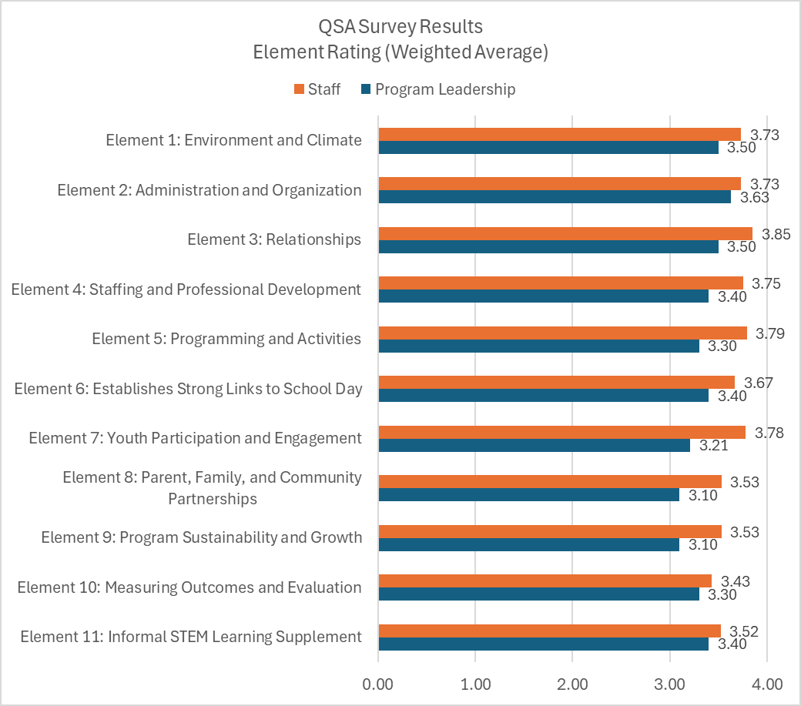
✓
of 11 (100%) Element Areas
11
rated at or above Standard
for
(3.00)
both Program Leadership and Staff
Highest
Rated Elements:
Program Leadership

2:
Administration and Organization (3.63)
1
Environment and Climate
(3.50)
:
3

:
Relationships (3.50)
Program Staff
(3.85)
3
. Relationships

5:
Programming and Activities (3.79)
7
:
(3.78)
Youth Participation and Engagement

Performance Indicator:
% of program advisors will complete the NYSAN QSA Survey
100
.
n=2 for Pre and Post,
(
☑

PI Achieved
)
% of program staff will complete the NYSAN QSA Survey
80
.
n=10 of 14 = 71%
(
PI Partially Achieved
)
QSA Survey Summary Results: Program Leadership and Staff
QSA Survey Areas of Focus
# Attributes at or Above Standard
Program Leadership: 62 of 67 (93%)
Suggested Areas of Focus/Prioritization for Action Plans Program Staff: 51 of 51 (100%)
Attributes Rated Below Standard (by 1 or more advisor or staff)

Element 2: Administration and Organization
- Establishes clear attendance and participation expectations.
Element 4: Staffing and Professional Development
- Maintains appropriate staff-to-participant ratio relative to the population.
Element 5: Programming and Activities

- Students are provided opportunities to provide feedback for enrichment offerings during the school year.
Element 7: Youth Participation and Engagement
- Enables participants to explore resources and issues in their community through projects and activities.
- Involves participants in the development of disciplinary practices.
Element 8: Parent, Family, and Community Partnerships
- Provides opportunities in which participants' work/projects are showcased.
Element 9: Sustainability and Growth
- The mission and goals are communicated to program staff.
- Accesses resources within the community by seeking support from and building relationships with businesses.
- Has an effective marketing strategy that publicizes the program and its achievements among the community.
Element 10: Measuring Outcomes and Evaluation
- Measures participant academic and behavioral progress.
- Summaries of evaluations are available to stakeholders.
- Measurable program goals and outcomes align with mission.
Element 11: Informal STEM Learning Supplement
- Structures STEM activities to move purposefully towards the understanding of a STEM idea or practice.

QSA Survey Areas of Focus
Staff Verbatim Comments
"
Valuable
ass
et to our school community
.
Many families
ar
e grateful for the experiences
their chil
dr
en have in the program."
"
We had a successful year promoting
student growth and SEL
in the
program.
My students excelled with STEAM
activities and the school newsletter.
Children felt comfortable and made
new friends in other classes.
I appreciate this program and I am
confident that parents do as well."
"
Some
unger groups were very
yo
challenging for one staff
large a
nd
me
m
ber
. Great program
a
nd very well run!"

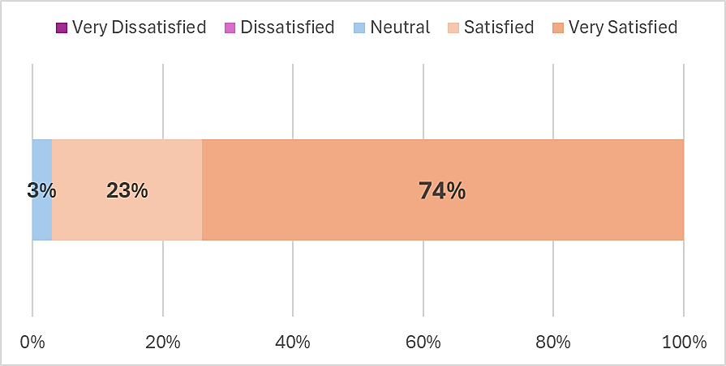
2025
Parent Survey
34
Sample Size
53
% Response Rate
+
/-11.6% Margin of Error
Ove
rall Satisfied with B.E.S.T Program
How child has benefited most:
79
% Enrichment activities
79
% Socialization with students
77
% Enjoys attending
71
% Positive interactions with staff
56
% Social Emotional Learning
44
% Academic Support/Tutoring
❑
%
97
faction Rate (positive net)
Overall Satis
❑
Three-quarters (7
4
%) are
Very Satisfied
with the Program
❑
High Levels of Sat
isfaction Across all Program Attributes
•
84
%
SA/A, th
e program has helped my child
perform better in school
•
93
%
SA/A, th
e program
provides adequate time and support to complete HW
•
97
%
SA/A the
program
staff are kind
and treat their child with respect.
"We are grateful for the
programs and opportunities
the children are provided."
2025
Parent Survey
Suggested Areas for Improvement
▪
9
% Additional days
of program (Fridays, less breaks, through end of year)
▪
6
% Streamline pick-up
▪
6
% Increased communications
about what the child is doing in the program
▪
3
% More of a focus on
tutoring
▪
3
% More of a focus on
social emotional learning
▪
% More activities with
3
movement
▪
3
% More
cultural
activities
▪
3
% More staff to serve students with
ADHS and/or sensory issues
▪
53
% Nothing / Positive comments about the program
"More staff or classes
in handling ADHS
students/
dysregulation/sensory
issues"
"Maybe the pickup
situation so it's not so
congested."
Attributes rated below 80% Strongly Agree/Agree*:
▪
Program staff
handles discipline problems
swiftly and appropriately (78% SA/A)
▪
My child is
making better decisions
(78
% SA/A
)
▪
My child is
getting along better with others
% SA/A
(74
)
*~25% neither agree nor disagree
Explicit SEL
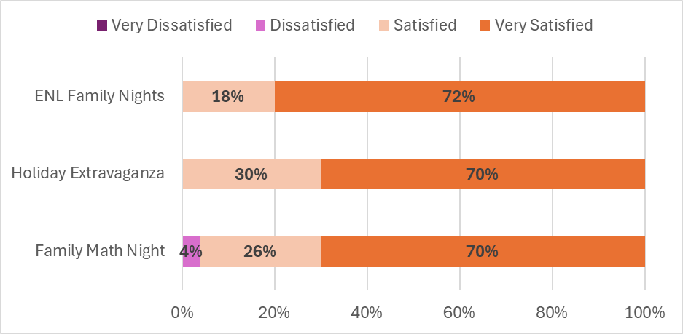
2025
Parent Survey
Satisfaction with Parent Engagement Activities
❑
High Lev
els of Awareness (>90%) and Attendance (>70%) at Parent Engagement Events
❑
Very High
Levels of Satisfaction across all three events (96%-100% Positive Net)
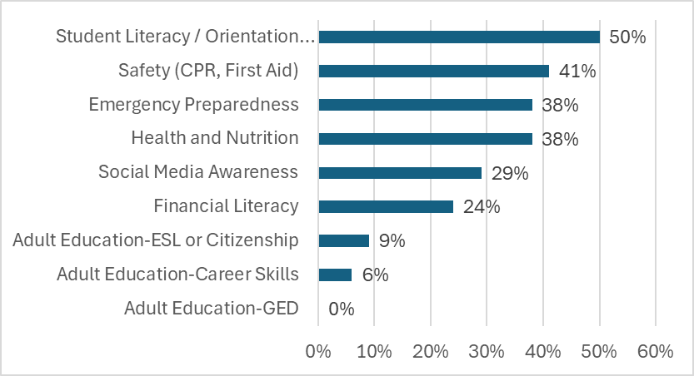
2025
Parent Survey
Interest in Parent-Focused Events
❑
High Level of I
nterest in
Student Literacy / Orientation
Programs (helping parents help child)
❑
Other topics t
o consider:
Safety, Emergency Preparedness
, and
Health and Nutrition


2025
Student Feedback – Qualitative Assessment
What do you like most about coming to B.E.S.T.?
❑
Time spent w
ith
friends
/
Seeing friends
from other classes /
Meeting new friends
(
laughter
)
❑
Hanging with

teachers and staff
(
positive environment
)
n=63 Students
Grade 2: 5 Students
Grade 3: 19 Students
Grade 4: 39 Students




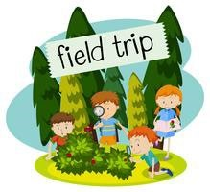
2025
Student Feedback – Qualitative Assessment
What types of activities do you like best?
❑
Going outside / Playground activities
❑
Arts and Crafts
❑
Running Club
❑
Movie Nights
❑
Field Trips
❑
Games (e.g., Booklit, board games)
❑
Big Buddy, Little Buddy Program



2025
Student Feedback – Qualitative Assessment
What o
ther activities would you like to see offered?
❑
Sports Clubs
(
basketball, football, soccer, volleyball, hockey, gymnastics, jiu-jitsu,
swimming, track
and field, ballet)
❑
Video Gami
ng / Time on iPad
❑
es
Board Gam
❑
Cooking / B
aking
❑
More Field Tr
ips
❑
Bring in pets
❑
STEM activiti
es (Earth Day activities, Roblox, Legos)
❑
Girl Scouts
❑
More arts an
d music (tie dye, drawing)
❑
Cosmetolog
y
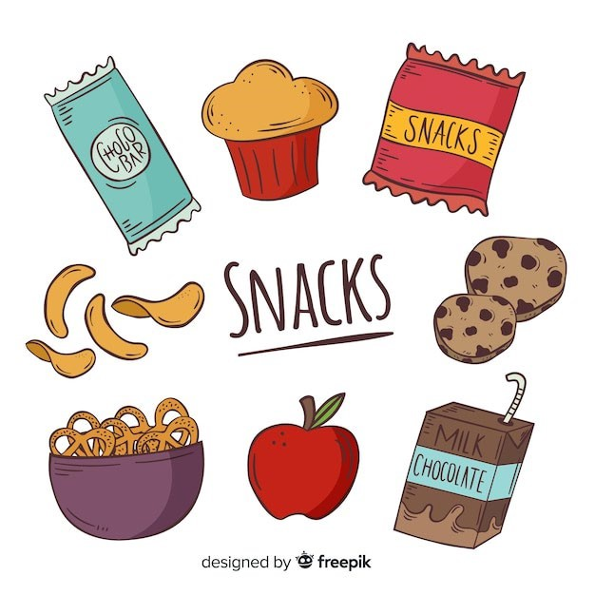

2025
Student Feedback – Qualitative Assessment
Suggested Changes to B.E.S.T.
❑
Better Snacks (quantity and more choices)
❑
Shorter bus ride home
❑
Downtime to socialize with friends

Recommendations - Programming
Tutoring and Academic Support
- Provide daily tutoring in ELA and Math skill-building during the first hour of the program (morning and after-school programs). => Create two academic sessions – ELA (M/T), Math (W/Th) AND
ELA and STEM Enrichment
- Be intentional about which activities/clubs 15-hour students are attending to achieve the ELA (Reading/Writing) and STEM indicator. =>> To meet the Academic Outcome:
➢ 65% of students with 30 hours of academics (tutoring, STEM, ELA) will demonstrate growth in AIMSWeb assessments.
AND
=>> Demonstrate that evaluation findings are used to inform programming
More tutoring is a suggested area of improvement from the Parent Survey
Students indicated an interest in more STEM activities
The structure of STEM activities moves purposefully towards understanding a STEM idea or practice = rated < standard in the QSA.
Social-Emotional Learning
- Provide more explicit project-based SEL related to feelings, expressing emotions in positive ways, accepting others who may be different, etc.
=> Dedicate a day per block to explicit SEL (aligned to behaviors in the program, getting along, and making better decisions)
AND
Youth Development
- Be intentional about which activities/clubs 15-hour students are attending to achieve Well-rounded and Physical Activity indicators. Include outdoor programming opportunities.
=>> To meet the Behavior/SEL Outcome:
➢ 70% of regular attendees (15+ hours) will demonstrate improvement in at least one positive behavior/SEL indicator (BIMAS).

Considerations for Continuous Program Improvement (Action Plans)
- Take a more careful look at STEM-related lesson plans to make sure there is a true STEM learning goal (hands-on, minds-on)
- Provide older students the opportunity to serve on a Youth Advisory to inform the type of enrichments and disciplinary processes
- Recruit a Teen Mentor from the High School to volunteer in the program (as a floater to sub in for aides and provide mentoring, etc.)
- Offer a family engagement event that includes showcasing students’ work/projects and showcasing work in the school (bulletin board)
- Brainstorm ways to increase parent involvement in the program (advisory board) and offer events on topics of interest and need. Consider utilizing community presenters and resources as needed to address needs identified through parent survey findings.
- Consider adding a ‘needs assessment’ to the enrollment form (e.g., parent needs, student needs, volunteer/advisory committee)
What are your top three concerns or needs for your child? Would you attend parent workshops or family events (Yes, No, Maybe)?
Are you interested in serving on the Advisory Committee? What’s one thing the program could do better to support you and your child?
- Consider ways/methods to increase communication with parents (e.g., newsletter at the end of the block that includes activities and key highlights from the evaluation findings)
- Continue preparing for the Site Monitoring Visit (most likely, next year)
- Update the program’s website page – post advisory evaluation updates (PPT), relevant program news, and successes (MI visit)  Document decision-making during advisory meetings in the form of Advisory Meeting Summary  Begin discussions related to long-term sustainability to include, but not limited to:
  - Identifying and building relationships with additional resources in the community
  - Developing a marketing strategy that promotes the successes of the after-school program among the wider community
  - Extended School Day Grant Program (Application in Nov-Feb timeframe) – funding (State) is more secure than 21C (Federal)
  - RECOVS funds – Second Step (Tier I or II), Enrichments – perhaps these funds could be used to cover explicit SEL activities
MEASUREMENT TOOLS
✓
Activity and Participant Attendance Tracking in Transition Spreadsheets (New Platform July 1st)
✓
Site Visit Observations
(2
/year at each site: Fidelity of Implementation Meeting-December 12, 2024 and OST
Tool-On-site March 27, 2025)
✓
QSA Program Advisory Committee Survey
(2
x annually – December/May
)
✓
QSA Staff Survey
(
annually spring
)
✓
Parent Survey
(annually spring)
✓
NYSED Teacher Survey
(
Grades 1-4, In-the-field
)
✓
Summative Assessment Data: AIMSWeb
(30+
hour students, annually
)
✓
BIMAS Data
(15+
hour students, prior and current year
)

Evaluator Contact Information
Laura Payne-Bourcy Consulting Services (LPB Consulting)
Lucy Allchin lucyallchin@lpbconsulting.net (585) 943-1273
Kelly Masters
KellyMasters@lpbconsulting.net
(585) 747-6302

