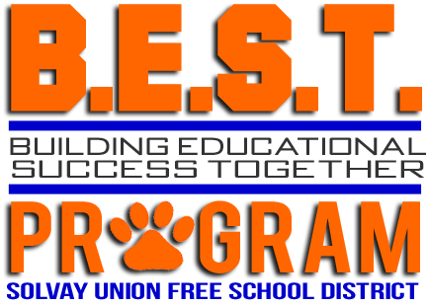

21st Century Advisory Meeting
March 21, 2019

AGENDA

- Welcome and Introductions
- Program updates 2018-2019
- Block 4 and end of year programming
- Summer 2019 programming
- State Review Feedback
- LPB Review

